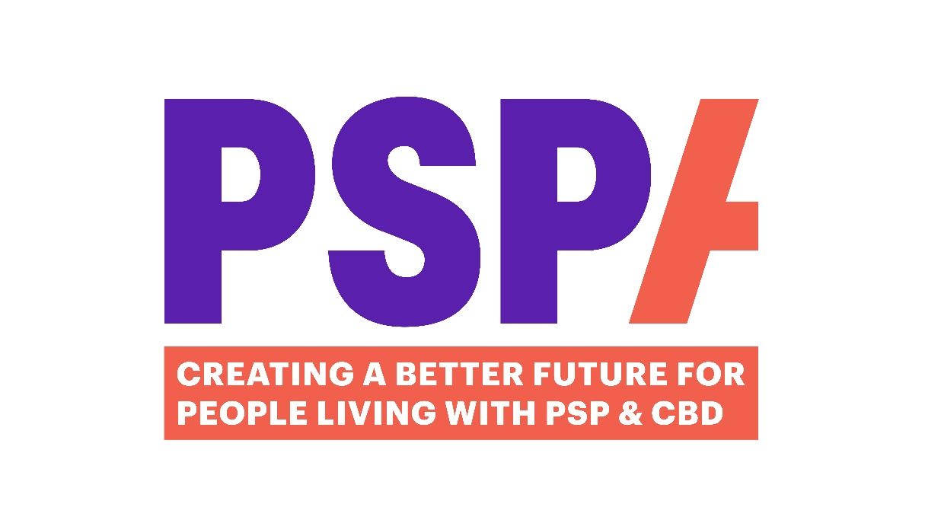

A Guide to setting up a Local Support Group

For Coordinators and Helpers

Contents Page

Welcome and the role of a Support Group 3-4
Starter Kit 4
Venue 4-5
Meetings Times 5-6
Your Role 6-7
PSPA Responsibilities 7-8
Finance and Expenses 8-9
Dealing with Difficult Behaviour 9-10
Boundaries 10
Confidentiality/Gifts 10
When it’s not working out 11
Ongoing Training and Support 11-12
Volunteer Hub 12


Welcome
Welcome to volunteering with PSPA. Our volunteering team is growing rapidly, and we currently have approximately 150 volunteers. The support groups are integral to the range of services offered by PSPA. Our local support group co-coordinators and helpers have played a large part in this rapid growth. Thanks to your involvement, our local support group network continues to go from strength to strength with many people living with PSP & CBD benefitting enormously as a result.
This guide has been developed because of the rapid growth of our local group network and the learning we have gained as a result. Your feedback told us there was a need for clarity in certain areas and this guide is in response to that need.
Although some of the information will not be new to our existing coordinators, we hope the guide will be useful to help define your role and to act as a reference point whenever needed. It is also intended to act as an induction for new coordinators and for those thinking about taking on the role.
If there is any part of the guide that you would like to discuss, please contact us on volunteering@pspassociation.org.uk and we will always be happy to talk it through.

What is a Support group?
Our local groups are the face of PSPA in local communities and provide direct support for people living with and affected by PSP & CBD. They are here to:
- Provide support to people living with PSP & CBD, their carers and families.
- Raise awareness and provide information.
- Offer a space where people can meet others and share experiences in a comfortable environment.

Meetings take place in person and/or via Zoom. Those that offer a combination of invited speakers and social time work well. Meetings often take place monthly though some groups hold them every 6 or 8 weeks. The aim is for the meetings to be:
- Friendly, welcoming and fun!
- Held in comfortable and appropriate surroundings.
- Held regularly and at a convenient time.
- Well planned and organised
Starter kit
PSPA will send you a pack of everything you will need to advertise, plan and carry out your monthly meetings.
- Pop up banner
- Stationery
- PSPA merchandise
- Leaflets and publications list to be displayed at the meeting.
Once your first meeting date has been set, your starter kit will be couriered to you and any additional supplies needed, can be obtained by contacting the volunteering team.

Venue
The venue you choose is important. You may find that a venue you are considering is not near where most potential group members live, and that travelling to the venue would be difficult for them. If in doubt, feel free to contact the volunteering team who will be happy to help identify the most suitable locations. Some are held at the local hospice, village hall, pub.
Key points to consider:
Location:
- Is it easy to find? On a good route? Are there bus stops nearby?
Accessibility:
- Is the building/room wheelchair accessible?
- Are there ramps/wide doors?

Car parking:
- Is parking available and are there disabled bays?
- If the venue has no parking, are there facilities nearby?
Seating:
- Is the seating suitable for people with mobility issues- comfortable stable and secure?
Toilet facilities:
- Are disabled toilet facilities available and accessible?
Refreshments:
- Offer hot and cold drinks.
- Provide straws for those that need.
- If you are considering food, ensure soft options are available.
When you have a venue in mind, it is always worth discussing your requirements with a member of staff.

Meetings
Times
- Daytime meetings are often more convenient for people living with PSP & CBD and their carers and are less tiring than evening ones.
- Weekend meetings may mean that extended family are able to attend.

Speakers
Some of our groups invite speakers along. The right speaker can be a major attraction at a meeting, giving advice and information on topics which people living with PSP & CBD may see as a benefit to them e.g. advice on benefits, complimentary therapies. Talks on research are always of interest, or you could invite the local neurologist, OT or SALT. The theme of a talk does not have to be related to PSP & CBD, but on history of the town for example.
From time to time, PSPA staff may also attend and talk about their role and give any relevant updates.

Setting Up
On arrival, set you banner up in a prominent position to guide people to the meeting location. Display some of the merchandise information sheets you received in your starter kit somewhere in the room.
We will provide you and any helpers with a PSPA T-shirt and lanyard with ID.
Arrange the tables and chairs in a setting that will encourage people to mix. Groups of tables work well. Set up refreshments in one area of the room. You will need to purchase any tea/coffee/milk, cake and biscuits prior to the meeting, unless it is provided by the venue. It may be an idea to consider having someone dedicated helpers to manage the refreshments at break time. Having someone taking and delivering drinks orders and another making them seems to work well.

Arrival of members
Make sure you greet everyone as they arrive, particularly those who are attending for the first time as they may be nervous. Offer to introduce people to one other. Watch out for anyone left on their own and help them to meet others.
You will need to have a signing in sheet which PSPA will provide in your starter kit and ask everyone who attends to put their name only on the sheet. Due to data protection, PSPA will keep all personal information and send out invites, reminders and anything else the coordinator may need.
End of the meeting
Remind people of the date of the next meeting

Your Role
Our local support groups provide an invaluable part of the PSPA service and make a huge difference to those who attend. Their aim is to provide a welcoming and friendly place for people effected by PSP & CBD, including family and friends, to meet up on a regular basis to share experience, information and just chat.
Key tasks/responsibilities:
- Source a suitable venue bearing in mind access requirements.
- Buy and organise refreshments.
- Act as host, welcoming members and encouraging conversation.
- Plan any group activities/speakers. PSPA can help with speakers.
- Ensure all attendees complete the Attendance Sheet- full name required. This will be included in your starter kit. Promptly return these to PSPA by email or post.
- The Support Group Coordinator is representing PSPA and therefore must follow all PSPA related policies and procedures and ensure the group works closely with PSPA.
- Complete and send back volunteer expenses form.
- Ensure any new members of the group who are not known to PSPA, complete a registration form. This will be included with your starter kit.
- Complete an accident form if necessary and promptly send back to PSPA.

The role of the coordinator is to facilitate the meeting, encourage conversation and bring people together. If a member of your group has a support issue, please always refer them directly to the Helpline, who have the skills, knowledge and links with healthcare professionals to best advise and support.
You may have a support group helper with which to share the above tasks. If anyone else starts to help in any capacity as the group progresses, please do let us know as we may need them to complete specific courses, a DBS check and include their role as a volunteer on our records.

PSPA Responsibilities
PSPA will take care of meeting administration to include:
- PSPA will send out invites to people on our database who live within a 30-mile radius of the venue’s postcode. The invite comes from PSPA, so no personal Coordinator details are included. We will send out any information to the group on behalf of the coordinator and will not give out any contact details of members due to GDPR.
- PSPA will provide Support Group Coordinators with posters containing the details of their support group meetings so they can advertise the meeting through their networks and within their communities.
- Support Group Coordinators are responsible for setting the dates for their meetings throughout the year. Sometimes it is not always possible, but it helps to plan the meetings a year ahead to ensure they are suitably publicised, and everyone informed.
- As soon as you have these dates, please inform Volunteering@pspassociation.org.uk so we can publicise on our website, social media and in PSPA Matters.
- Invitations are sent out by PSPA approximately 10 days before each meeting.
- Due to GDPR/data protection regulations, PSPA only will hold all personal information of attendees and will therefore send out any meeting invites and reminders. Meeting attendance sheets should therefore only list the names of the attendees.
- Insurance All our volunteers undertaking authorised roles are covered by PSPA Public Liability Insurances providing they are acting within the remit of the role.

Finance Procedure and Expenses
Expenses We strongly encourage all our volunteers to claim expenses monthly. Volunteers donate their time, and we would not want them to be out of pocket.
By claiming expenses, we can also gain an accurate picture of costs which is important for future budget planning.
If you really do not want to claim expenses, then please do still complete a form and state on it that you wish to donate your expenses back to PSPA.
Claim forms will again be in your starter kit but can also be emailed or posted to you by the volunteering team. They are also available on our Website under Volunteers Hub.

Finance Procedure
- Each group will be issued with a prepayment card preloaded with £250, to be used for refreshments and Hall Hire. If possible, please ask the Venue to invoice PSPA directly and we will pay this separately.
Please provide the following details to enable us to order you a card:
- Name of the person to whom the card is to be issued (this name will appear on the card)
- The address where the card should be sent
- Confirmation that your group requires a card

- Log all expenditure/fundraising on the Support Group Expenditure log which can be found on the “Volunteering Hub” section of our website. Please complete and return to Lavonne at Volunteering@pspassociation.org.uk at the end of each month along with the receipts.
You can either email a photo of the receipts or, if you prefer, request pre-paid envelopes to post the receipts and expense/income forms back to us. Once received and reconciled, your card will be topped up accordingly

- If your group kindly fundraises for PSPA, you will now be issued with a paying in book, and we ask that you deposit the funds into your local Lloyds bank or Post Office. If you want to pay in cash but do not have a Lloyds near you, please let me know.
Please note:
Any PSPA money lost or stolen from the private home of a volunteer is covered up to £1000 only if it is in a locked safe.
Public Liability Insurance indemnifies PSPA and its groups against risks which are our responsibility. It does not cover anything which occurs as the result of another party’s negligence. If a slate fell from a roof in a pub where a meeting was being held and injured one of the members, the liability rests with the property owner. It is likely that their insurance covers this, but it may be worth checking when you hire the venue. Your event may cost an additional premium to cover but could be claimed back from PSPA.
If you are not sure if an event/activity you are hoping to hold as part of you support group meetings is covered under the insurance, please contact us.
Dealing with difficult behaviour
We are all aware and have experienced a group situation where a meeting is dominated by one or two people. This can have a detrimental effect on the rest of the people attending and needs to be handled with confidence by the group coordinator. It is important to avoid a situation where people are put off from attending because of the behaviour of one person.
Here are some suggestions to deal with such situations.
- Break people into small discussion groups.
- A friendly interjection by the coordinator – “can we listen to one person at a time”. It is important to make eye contact with the person.
- Interrupt the conversation dominator and encourage others to share.
- Make it personal. “I can see you have something to say- we’ll come back to you when Fred has finished”.
- If it is persistent, you may need to speak to them individually after the meeting to share your concerns. This may sound daunting but sometimes is the only way and future attendance at the group by others may depend on it.

Boundaries
Support Group Coordinators may be asked to visit someone in their home. This is beyond the remit of the role and should not take place.
However, we do have the Befriending Service in place to offer such support. A trained volunteer can visit a family for up to 12 months, depending on circumstances, to help navigate a new diagnosis, isolation, or a time of crisis. The volunteer offers emotional support, provides information and can signpost to other organisations who may be able to help.
Confidentiality
You will already have a copy of our Confidentiality Policy and have completed our online GDPR course. However, we do need to think about what this means to us as individuals and to PSPA. It is easy to break confidentiality without realising.
Gifts
We ask that volunteers do not personally accept any gifts or donations if offered to them by people attending the group. Gifts and donations to PSPA are gladly accepted but need to be recorded and officially acknowledged.
When it’s not working out
We place great value on the work of all our volunteers and our aim is to ensure each volunteer enjoys a rewarding and fulfilling experience during their time with us.
However, there may be rare occasions when the behaviour of a volunteer can cause concern or have a negative impact on the aims of PSPA. We have a Volunteer Problem Solving Policy to guide the individual though difficult situations. We will always endeavour to resolve issues informally by discussion, but the policy lays out the stages of the procedure if concerns cannot be resolved in this way.
In the same way we aim to create an environment where volunteers feel valued and listened to. However, we understand there may be occasions where volunteers have concerns or complaints, so we have implemented a Complaints procedure to enable an individual to raise these concerns formally. The procedure provides an open and fair way for volunteers to make known their problems and, we hope, will lead to a speedy resolution.

Ongoing Training and Support
We provide a comprehensive support and development package for our volunteers:
Wellbeing Package
We recognise that this role can, at times, be emotional and trigger your own experiences. We have therefore put a wellbeing package in place, to provide emotional and wellbeing support to include:
- Well-Being Helpline and App: 080 107 6585 quoting UK Healthcare and scheme number 72740.
- Gym and Spa discounts:
Gym Discounts: www.mygymdiscounts.co.uk Passcode: ukh
- Benefits Hub for cinema, retail and travel discounts: https://pspa.benefithub.com Enter referral code:9P9HSK

Ad Hoc Training courses
Prior to your first meeting, will be required to complete short online Safeguarding and GDPR course
We will get in touch if there are any further courses that we need you to complete.

Annual Volunteer Feedback Survey
You will be sent an annual, short questionnaire asking you for feedback about your role to include what is working, what could be improved and ideas for the future.
There is also an option to have a 1:1 over Zoom, to discuss things in more detail.
Remember, you do not have to wait for the annual review if you need to discuss anything. You can contact Lavonne at Lavonne.McCormack@pspassociation.org.uk at any time to share ideas, thoughts, good news and even frustrations.

Quarterly Support Group Coordinator/Helper Meetings
We ask that you attend as many of these as possible to keep up with any important updates and procedures. They also give you the opportunity to meet other volunteers and exchange experiences.

Support Group Coordinator Briefing
A newsletter with any relevant PSPA and Volunteer related updates will be emailed to you every 2 months, for your info and to disseminate with you members.

Annual Volunteer Development Day
An opportunity to meet and network with volunteers in different roles. The day will include PSPA speakers, activities and training sessions, and give you an opportunity to feed your ideas into PSPA. There are many opportunities to provide feedback.

Volunteer Hub
We have a dedicated Volunteer Hub on our website where you can find and download all policies and procedures. The Hub also contains a blog as well as other resources to help with your role.
https://www.pspassociation.org.uk/volunteering/volunteer-hub/

Finally, please enjoy your role as Support Group Coordinator/ Helper and of course, if you have any questions or concerns, contact:
Lavonne McCormack PSPA Volunteering Coordinator at:
Volunteering@pspassociation.org.uk

