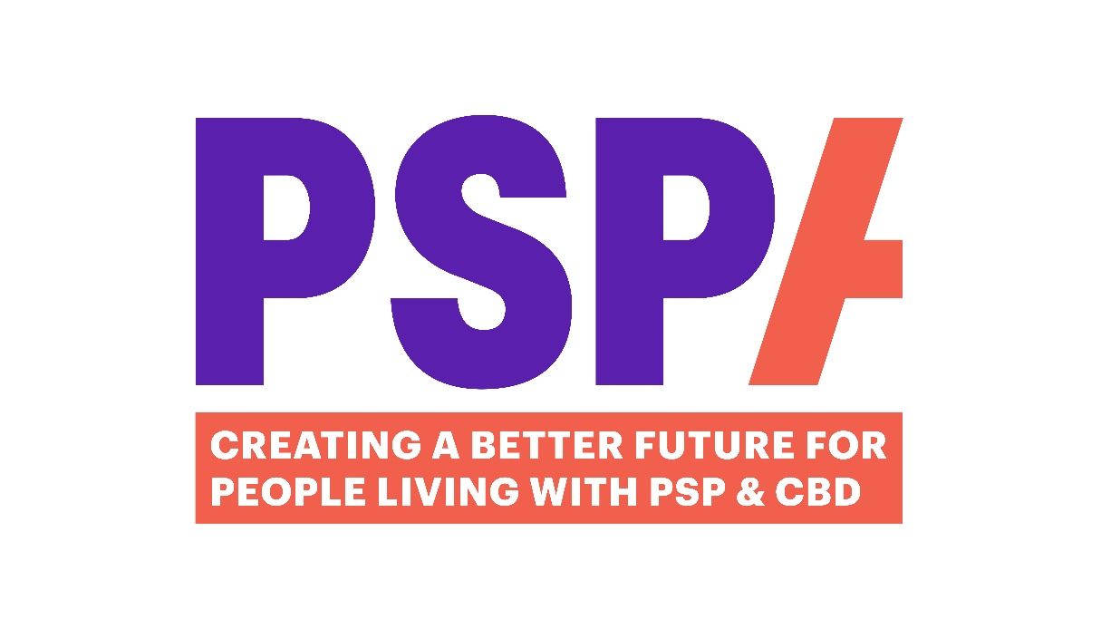
A Guide to
Micro Volunteering

Make a big difference in small ways
Contents Page

What is Micro Volunteering 2

Roles 2

Cheer Point Helper role 3

FAQs/Important Information 4
Micro Volunteering
volunteer guide

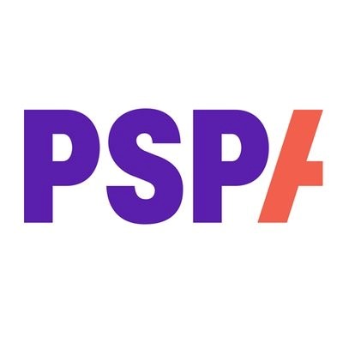
What is Micro Volunteering
Micro Volunteering means helping as and when you can at one-off events, short-term projects or small tasks that fit around your lifestyle. Whether you have an hour a day or a day a year, your contribution will help us continue supporting people living with PSP (Progressive Supranuclear Palsy) & CBD (Corticobasal Degeneration), as well as their families and friends.
Your skills and experience can offer vital support to projects or events, whether you volunteer once or on an ongoing basis.

What you could be doing

As a PSPA Micro Volunteer, you could get involved in a variety of ways:
- Cheer Point Helper - Cheering on PSPA fundraisers at events like the London Marathon or Great North Run.
- Community Champion - Representing PSPA at community fundraising events — talking about our services, collecting donations and raising awareness.
- Events - Helping at events such as Family and Friends Day or Volunteer Development Day.
- Using your skills and knowledge to help shape a new campaign or resource.
- Sharing your views as part of a focus group

Cheer Point Helper

Responsibilities
- Help to secure the cheer Point spot for the event and put up banners and flags.
- Pack up at the end of the event.
- Encourage runners as they pass by- they will be wearing PSPA tops.
- Be an ambassador for PSPA by speaking with other supporters and answering any questions they may have.
- There are often Roving Reporters at these events so be prepared to give an on-the-spot interview and raise awareness of PSP & CBD.

Social Media
If you tweet or Instagram on the day, please use the hashtag #TeamPSPA and tag us on @TeamPSPA so our Social Team can pick these up and share them.

Dress Code
Preferably wear PSPA t-shirts, or hoodies, casual and comfortable clothing and shoes. Please request a PSPA t-shirt if you don’t yet have one. They are available in sizes S-XXL. If you are planning to wear your shirt over a jacket for visibility, size up where you can. We also have PSPA beanies or baseball caps which may be available.

Weather
The race will go on regardless of weather, so please check the forecast before setting off, and dress appropriately. Be prepared with sunscreen if a clear bright day, and if weather is poor, hats are usually better in crowds than umbrellas.

Refreshments & Comfort
There are several places offering drinks and food. Toilets are available nearby. There are also areas to step away from the crowds when needed – the day can be very busy, very loud, and overwhelming for some. Make sure to check in with the lead at your cheer point to let them know when you need a break, or if you need to withdraw completely. We want to ensure that you are looked after and get home safely.

FAQs & IMPORTANT INFORMATION

- Who should I contact if I am running late or need any assistance?
Please ensure you ask the member of staff organising the event, for a contact name and number, before you are due to volunteer.
If you are running late, unable to attend for any reason, or need assistance during the event, please call your lead contact.

- Emotional wellbeing
Volunteering at events and talking to people from the PSP & CBD community can at times be quite emotional and trigger memories from your own personal experiences. If you become upset during the day, please do make your PSPA contact aware, so we can support you and make sure you are looked after. We do not want you to go through this by yourself.
We also have a wellbeing package in place, to provide emotional and wellbeing support to include:
Well-Being Helpline and App: 080 107 6585 quoting UK Healthcare and scheme number 72740.

- What should I wear?
Preferably a PSPA T-shirt. The Volunteer Coordinator or the PSPA member of staff leading the project will arrange this before the event.

- ID Badge
Please remember to bring and wear your ID badge if this is a requirement for your volunteering role.

- How do I claim my travel expenses?
Volunteers can claim travel expenses by completing an expenses form which you can find on the Volunteering Hub: https://www.pspassociation.org.uk/volunteering/volunteer-hub/guidelines/ .

You can request a paper copy by emailing Volunteering@pspassoication.org.uk. Please complete and send back with any receipts to the above address. We do not want you to be out of pocket, so we aim to process your expenses asap.

If you have any questions at all, about Micro Volunteering, please contact the Volunteering Coordinator – Lavonne- on Lavonne.McCormack@pspassociation.org.uk

