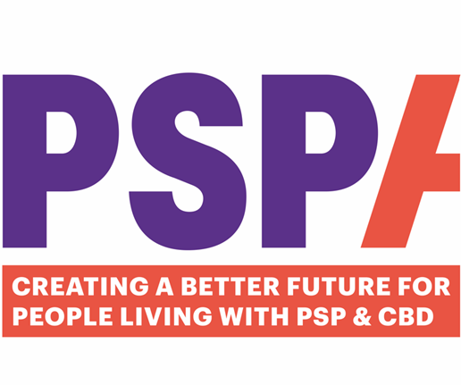
Evening Helpline Volunteer

Contents Page

Welcome and role & Responsibilities 3

Important Information 4

Policies 4

Ongoing Training and Support 5

Volunteer Hub 6

FAQs 6


WELCOME
Welcome to volunteering with PSPA as an Evening Helpline Volunteer. Our team is growing rapidly, and we currently have approximately 150 volunteers, 11 of whom support the Helpline.
Helpline Volunteers are integral to PSPA. They enable us to extend our Helpline service into the evening on weekdays, giving families affected by PSP & CBD the opportunity to reach out for emotional and practical support when they need it.

ROLE AND RESPONSIBILITIES
The main purpose of the Helpline Volunteer role is to answer calls to the dedicated helpline, provide a listening ear, offer emotional support, and signpost callers to relevant information where appropriate.
Calls can vary in nature. Some people may simply need space to talk and share how they are feeling, while others may be looking for information or guidance about specific topics. In some cases, callers may need to be referred to another service or to a member of the PSPA team.
A key part of the role is listening with empathy rather than giving advice. You will also need to record important information from the call, particularly if a referral is needed, so that the relevant Helpline Care Navigator can follow this up the next working day.

Please be aware that there may be shifts where you do not take any calls.

TIME COMMITMENT
The Evening Helpline operates Monday to Friday from 7–9pm. Volunteers are usually asked to support 2–3 shifts per month, with each shift lasting two hours.
The Helpline Manager prepares the rota on a quarterly basis. Before each new rota period, you will be contacted and asked to share any dates over the following three months when you are unavailable.

PAPERWORK
You will need to complete a form after each call you take, ensuring that you obtain all the data fields required. The form will be emailed to you at the final stage of the recruitment process. This must be emailed- password protected- to the Helpline Manager before the end of your shift.

MAKING CALLS
You can use a landline or mobile. All calls will be routed to your phone via our cloud call system, so your personal number is not revealed. If you miss a call on your shift, please do not return the call as this will release your number. If using a mobile, you must disable this before your shift.

IT SKILLS
You will need basic experience using Microsoft Office, including the ability to password-protect a Word document.
At the end of each shift, you will be asked to complete a short form for each call taken and email the password-protected document to the Helpline Manager.

POLICIES
Please ensure that you are familiar with our Confidentiality and Safeguarding Adults at Risk of Harm Policies, as well as reading the Volunteer Policy. All of these can be found on the Volunteer Hub:
https://www.pspassociation.org.uk/volunteering/volunteer-hub/
Ongoing Training and Support
We provide a comprehensive support and development package for our volunteers:
Wellbeing Package
We recognise that some roles can be emotional and trigger your own experiences. We have therefore put a wellbeing package in place, to provide emotional and wellbeing support. This includes:
- Well-Being Helpline and App: 080 107 6585 quoting UK Healthcare and scheme number 72740.
- Gym and Spa discounts:
Gym Discounts: www.mygymdiscounts.co.uk Passcode: ukh
- Benefits Hub for cinema, retail and travel discounts: https://pspa.benefithub.com Enter referral code:9P9HSK

Ad Hoc Training courses
Prior to your first shift, will be required to complete short online Safeguarding and GDPR course. We will get in touch if there are any further courses that we need you to complete.

Annual Volunteer Feedback Survey
You will be sent an annual, short questionnaire asking you for feedback about your role to include what is working, what could be improved and ideas for the future.
There is an option to have a 1:1 over Zoom, to discuss your comments in detail.
Remember, you do not have to wait for the annual review if you need to discuss anything. You can contact Lavonne at Lavonne.McCormack@pspassociation.org.uk at any time to share ideas, thoughts, good news and even frustrations.

Annual Volunteer Development Day
Provides an opportunity to meet and network with volunteers. The day will include PSPA speakers, activities and training sessions, and give you an opportunity to feed your ideas into PSPA.

WhatsApp Group
Peer support from other Helpline Volunteers
VOLUNTEER HUB
We have a dedicated Volunteer Hub on our website where you can find and download all policies and procedures. The Hub also contains a blog as well as other resources to help with your role.
https://www.pspassociation.org.uk/volunteering/volunteer-hub/

FAQs
- Who should I contact if I am unable to attend a shift?
Please email the Helpline Manager on helpline@pspassociation.org.uk.
If it is very short notice, you can ask another member of the volunteer team via the Helpline WhatsApp Group, if they can help.

- Who do I contact if I want to discuss an issue I had on shift?
Please contact the Helpline Manager on the above Helpline address initially, saying that you would like to speak about your shift. She will then contact you directly.

- Who do I contact for further information about the wider Volunteering team? It may be talk about attending the Bi-Annual Volunteer Meeting on Zoom, or to provide feedback about the Volunteering Service.
Please email the Volunteer Coordinator on lavonne.McCormack@pspassocaition.org.uk

- Who should I contact if a call triggers my own personal experience and I need support?
You can always talk to your staff contact about an emotional shift. You can also get peer support from the Volunteer WhatsApp group. Lastly, you can use the Wellbeing Helpline mentioned in the ongoing support and training section.

Finally, please enjoy your role as an Evening Helpline Volunteer, and welcome on board.

