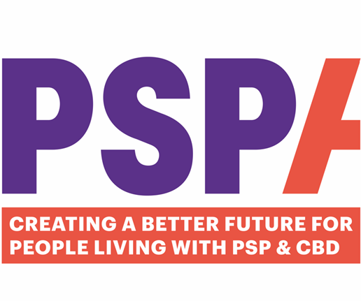
Education Volunteer
Guide

Contents Page

Welcome and Role & Responsibilities 3

Role & Responsibilities 4

How to arrange a Talk 4

Useful Talk information 4

Policies 5

Ongoing Training and Support 5 & 6

Volunteer Hub 6

FAQs 6


WELCOME
Welcome to volunteering with PSPA as an Education Volunteer.
Our volunteer team is growing rapidly, and we currently have approximately 150 volunteers across the UK. Of these, 11 are Education Volunteers (EVs) who help raise awareness of Progressive Supranuclear Palsy (PSP) & Corticobasal Degeneration (CBD) by delivering educational talks.
At present, our Education Volunteers are based in the following areas: Berkshire, Surrey, Devon, Lincoln, Manchester, Bedfordshire, Hampshire, Leicestershire, London, Norfolk and Stockport.
We are grateful for your support in helping to increase awareness and understanding of PSP & CBD among health and social care professionals and the wider community.

ROLE AND RESPONSIBILITIES
The primary role of an Education Volunteer is to deliver awareness presentations to local care and nursing homes that would like to increase their staff’s understanding of PSP & CBD.
Volunteers will be provided with a PowerPoint presentation to support these sessions. This includes information about the history of PSPA, the services the organisation provides, common signs and symptoms of PSP & CBD, and guidance on how people can access support services.
Presentations are ideally delivered in person but can also be delivered via Zoom if there is no volunteer available locally.
Volunteers are asked to have personal experience of PSP or CBD, as healthcare professionals who attend the education talks consistently report that personal experiences shared by volunteers have the greatest impact.
Education Volunteers may also be invited to speak to local community organisations about PSPA and the work the charity does. A separate presentation is available for these types of talks.
To support Volunteers, PSPA provides a letter template that can be used when contacting local care and nursing homes to introduce themselves and the education service.

How to arrange a Talk
Once we have received a request from a care or nursing home, the Director of Service Improvement and Development (DoSIaD) or Volunteer Coordinator (VC), will email our group of Education Volunteers and ask if anyone is available. The Volunteer is then responsible for contacting the care home manager directly and arranging a convenient date and time to deliver the talk. If there is no volunteer in the region, we would then deliver over Zoom.

Useful Talk Information
Presentations typically last 45 minutes to one hour, depending on the number of questions asked.
Please do not change any of the presentation slides without prior agreement from the DoSIaD.
You are encouraged to share your personal experiences of PSP or CBD, as feedback from Health and Social Care Professionals (HSCPs) indicates this is often the most impactful part of the session.
If the presentation is delivered via Zoom, PSPA will send the meeting link to both the volunteer and care home manager. You will be admitted to the meeting 15 minutes before the start time and made host.
Please ensure you complete the attendance sheet and return it to the DoSIaD after the presentation.
A Reflective Practice Form should be completed after each presentation.
POLICIES
Please ensure that you are familiar with our Confidentiality and Safeguarding Adults at Risk of Harm Policies, as well as reading the Volunteer Policy. All of these can be found on the Volunteer Hub:
https://www.pspassociation.org.uk/volunteering/volunteer-hub/

Ongoing Training and Support
We provide a comprehensive support and development package for our volunteers:
Wellbeing Package
We recognise that some roles can be emotional and trigger your own experiences. We have therefore put a wellbeing package in place, to provide emotional and wellbeing support. This includes:
- Well-Being Helpline and App: 080 107 6585 quoting UK Healthcare and scheme number 72740.
- Gym and Spa discounts:
Gym Discounts: www.mygymdiscounts.co.uk Passcode: ukh
- Benefits Hub for cinema, retail and travel discounts: https://pspa.benefithub.com Enter referral code:9P9HSK

Ad Hoc Training courses
Prior to your first presentation, you will be required to complete a short online GDPR course. We will get in touch if there are other courses you need to complete.

Annual Volunteer Feedback Survey
You will be sent an annual, short questionnaire asking for feedback about your role to include what is working, what could be improved, and ideas for the future.
There is an option to have a 1:1 over Zoom, to discuss your comments in detail.
Remember, you do not have to wait for the annual review if you need to discuss anything. You can contact Lavonne at Lavonne.McCormack@pspassociation.org.uk at any time to share ideas, thoughts, good news and even frustrations.

Annual Volunteer Development Day
Opportunity to meet other volunteers. The day will include PSPA speakers, activities and training sessions, and give you an opportunity to feed your ideas into PSPA.
WhatsApp Group
Peer support from other Helpline Volunteers

VOLUNTEER HUB
We have a dedicated Volunteer Hub on our website where you can find and download all policies and procedures. The Hub also contains a blog as well as other resources to help with your role.
https://www.pspassociation.org.uk/volunteering/volunteer-hub/

FAQs
- Who should I contact if I am unable to attend my presentation or have any issues?
Your contact is the Director of Service Improvement and Development. Please contact her directly on: Carol.Amirghiasvand@pspassociation.org.uk or 01327 356137.

- What do I wear for an In-Person presentation?
During the recruitment and induction phase, you should have received an ID badge and lanyard as well as a PSPA volunteer t-shirt. Please wear these during each presentation. If you have not received either, please contact the VC at Volunteering@pspassociation.org.uk.

- Who do I contact for further information about the wider Volunteering team? It may be about attending the Bi-Annual Volunteer Meeting on Zoom, or to provide feedback about the Volunteering Service. Please email the Volunteer Coordinator on lavonne.McCormack@pspassocaition.org.uk

Finally, please enjoy your role as an Education Volunteer, and welcome on board.

