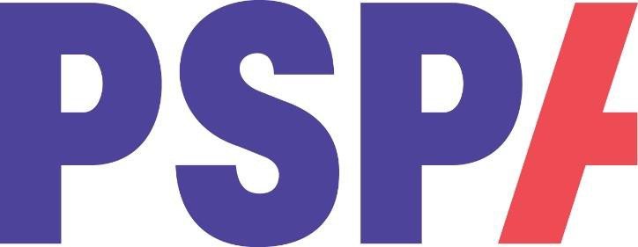

VOLUNTEER PROBLEM SOLVING POLICY

PURPOSE
This policy sets out a clear, supportive and fair approach to resolving any issues that may arise during a volunteer’s involvement with PSPA. Its purpose is to encourage constructive dialogue, early problem-solving, and positive outcomes. It also outlines the routes to support available to volunteers.

SCOPE
This policy applies to PSPA volunteers across all roles and activities. It aims to ensure clarity, fairness, consistency and good communication when concerns or difficulties arise.

KEY PRINCIPLES
PSPA is committed to supporting volunteers and resolving issues constructively. The following principles guide this policy:
- Early resolution is encouraged wherever possible.
- Volunteers will be treated with dignity and respect.
- Concerns will be listened to and taken seriously.
- The approach will remain supportive, proportionate and solution focused.
- Confidentiality will be respected where possible.
- Volunteers will be kept informed throughout the process.

INFORMAL PROBLEM SOLVING
Most issues can be resolved informally through open discussion and early support. Volunteers are encouraged to raise concerns as soon as possible so that they can be addressed quickly and positively. Depending on the situation, volunteers may seek support in the following ways:
Volunteer WhatsApp Group
Many volunteer roles have a WhatsApp group. This can be used to discuss general issues or seek advice from fellow volunteers. However, confidential, or sensitive matters should be raised directly with staff.

Quarterly Volunteer Meetings
Where available, volunteers may raise questions, concerns, or suggestions at their relevant quarterly volunteer meeting.

Contact the Volunteer Coordinator
Volunteers are encouraged to contact the Volunteer Coordinator in the first instance. They will listen to the concern and, if necessary, direct the volunteer to the appropriate member of staff responsible for their role.

Email: volunteering@pspassociation.org.uk
Telephone: 01327 362461

In many cases, a discussion or clarification will resolve the issue quickly.

FORMAL PROBLEM SOLVING
If a concern cannot be resolved informally, or if the issue is more serious, a more formal approach may be required.
This may include:
- A meeting with the Volunteer Coordinator and/or relevant staff member
- Gathering information from those involved
- Identifying actions to resolve the issue
- Agreeing any changes, support or guidance needed
If necessary, the matter may be escalated to the Director of Service Improvement & Development for further review.
Volunteers may be accompanied to meetings by another volunteer if they wish.

POSSIBLE OUTCOMES
Outcomes following a problem-solving discussion may include:
- Additional support, guidance or training
- Clarification of role expectations
- Agreed changes to volunteering arrangements
- Mediation between volunteers
- A temporary pause in volunteering
- In rare cases, ending the volunteer arrangement
Any actions will be proportionate and aimed at achieving a positive outcome where possible.

SERIOUS CONCERNS
Concerns relating to safeguarding, inappropriate behaviour, misconduct, or harm to others will be treated seriously and may require immediate action.
This may include:
- Immediate escalation to the appropriate staff member
- Temporary suspension of volunteering activities while the matter is reviewed
- Following PSPA’s safeguarding or complaints procedures

SUPPORT FOR VOLUNTEERS
PSPA values the contribution of its volunteers and is committed to ensuring they feel supported.
Volunteers will receive:
- Clear communication throughout the process
- Guidance and support from staff
- The opportunity to share their perspective

CONFIDENTIALITY
All concerns will be handled sensitively. Information will only be shared with those who need to be involved in resolving the issue.

RECORD KEEPING
Where necessary, a brief record of concerns and actions taken may be kept by PSPA. Records will be stored securely and handled in line with data protection and GDPR requirements.

RELATED POLICIES
This policy should be read alongside other relevant PSPA policies, including:
- Volunteer Complaints Procedure
- Safeguarding Policy
- Volunteer Code of Conduct
Review Date: March 2028

