   Carer’s Cards & Passports Handout

As a carer it is recognised that you are entitled to support that makes your life easier through various carer’s cards.

There are national and local cards, plus ‘passports’, this handout goes through what might be available.

NATIONAL CARER’S CARDS

**Carers Card UK**

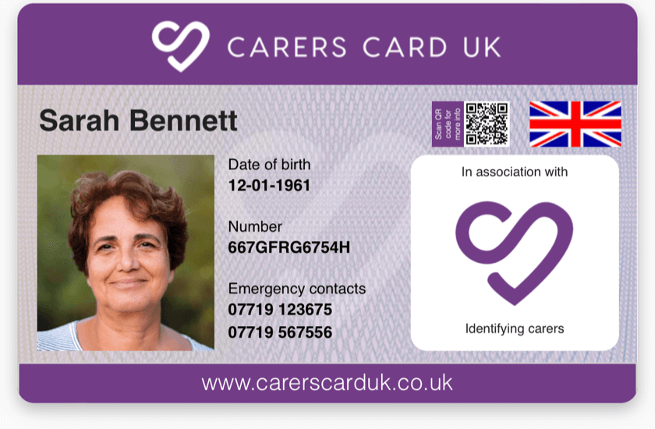

Founded by childhood friends whose parents were carers for their grandparents, this is advertised as the no.1 carers card, this claims that on average, carers save £20 a month. As well as offering discounts, Carers Card UK includes 2x ‘In case of emergency (ICE) contacts for you printed on the front of the card and access to wellbeing resources.

You can also have a ‘Carers Emergency Plan’ logged with Carers Card UK. This can be added to the card with a QR code (like a bar code) that can be accessed by using a mobile phone camera and then answering a security question. You can circulate the Plan to trusted people, such as your emergency contacts, so when someone such as a paramedic gets in touch with them, they help put it into action. No details are shared with third parties.

They recognise that not all carers will have any official documentation and say they don’t create barriers to registration.

The cost is £8 for 2 years.

Website: [Carers Card UK - Carers ID Card](https://www.carerscarduk.co.uk/)

**National Carer’s Card**

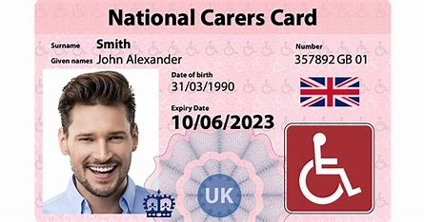

The original carer’s card, this again doesn’t require documentation as proof of eligibility and helps you to access venues as a recognised carer and receive special discounts from many retailers.

It includes a QR code that can be scanned to see who your emergency contacts are, although this relies on people having smartphones to do so.

The cost is £20 for two years

[National Carers Card ⎜Apply for a carers card UK](https://www.nationalcarerscard.org.uk/)

LOCAL CARER’S CARDS

Many councils and/ or area carer’s associations have a form of carer’s card giving you recognition, savings and access to events for free of with a discount.

Here are a couple of examples:

Gloucestershire Carers Aware Discount Card [Carer Aware Discount Card - Gloucestershire Carers Hub](https://gloucestershirecarershub.co.uk/carer-aware/carer-aware-discount-card-2/)

Lanarkshire Carers Card [Carer Card - Lanarkshire Carers](https://lanarkshirecarers.org.uk/services/carer-card/)

OTHER CARDS

**UK Cinema Association** **CEA CARD**

Carers go free with a loved one each time they go to the cinema together. It is currently £6.50 for a year and entitles you to ONE free ticket for someone to accompany a person with extra needs to the cinema to provide the assistance needed during a visit. To get the free ticket, you will need to purchase a full price ticket for the same performance.

The free ticket is provided on the assumption that the person who accompanies you can provide you with appropriate assistance, this might include

* helping you move around the cinema including finding and taking a seat;
* helping you leave the cinema in the event of an emergency;
* accompanying and/or helping you use the cinema's toilets;
* helping you buy refreshments.

Website address is: [Home - CEA Card](https://www.ceacard.co.uk/)

**ACCESS CARD Nimbus**

This card is for those with extra needs / disabilities and was developed in response to frustrations shared by disabled people and live music promoters in how disability was evidenced and venues struggles in having to interpret the information. The aim was to produce a single consistent method of communication between customer and provider.

The card is widely accepted at major event venues across the UK and beyond. There is a system of boxes at the bottom of the card that show what needs a person has e.g. wheelchair use, assistance of 1 other person, assistance dog used, if can walk less than a certain distance etc. There is recognition of a need for a carer so you can be recognised alongside your loved one.

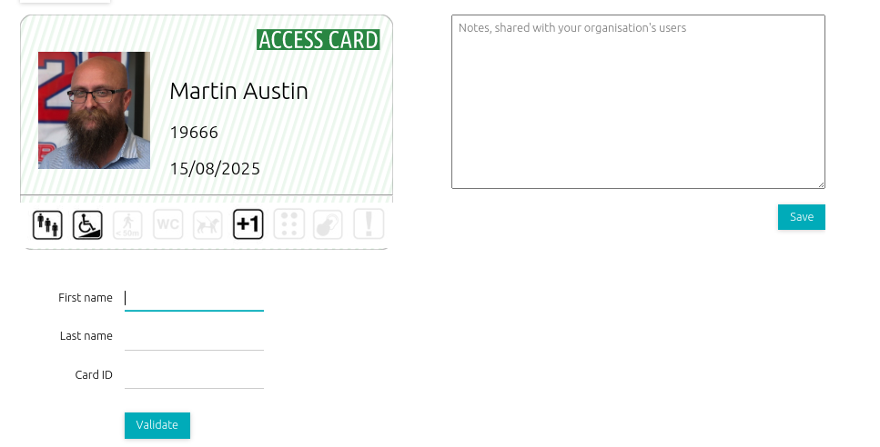

[Nimbus Disability: Innovation for an accessible future](https://www.nimbusdisability.com/services/access-card-and-nos/)

CARERS PASSPORTS

The term ‘carer passport’ refers to a record that is sometimes used by services you may use, employers or others to document you are a carer. These should then link to what support or services you might need. They aren’t yet widespread but are increasing and can be found offered in many different areas of society.

Here is a 1min 44sec video from Carers UK defining [What is a Carer Passport? - YouTube](https://www.youtube.com/watch?v=oUdC_ZhDp-s) and this dedicated website talks through how carers passport schemes can be set-up by organisations: [Home | Carer Passport Schemes](https://www.carerpassport.uk/)

Some employers have schemes; these often include guidance for conversations built around lists or maps of questions to find out how carers working for them can be best supported. If you are working, you could ask if your employer has one. Here is an example of what the Government uses for staff: [Carer's Passport - GOV.UK](https://www.gov.uk/government/publications/carers-passport)

You may also find these on offer in NHS Trusts for you, here is an example: [Carers' passport - South West Yorkshire Partnership NHS Foundation Trust](https://www.southwestyorkshire.nhs.uk/service-users-and-carers/carers-support/carers-passport/)

Another example is one that helps service personnel balance caring responsibilities with work: [Armed Forces Carer's Passport - GOV.UK](https://www.gov.uk/guidance/armed-forces-carers-passport)