 Medication Information for Carers

Introduction

This handout looks at the management of medication, it does not cover the range of prescriptions for those living with PSP and CBD. The drugs currently available for PSP and CBD are generally prescribed to alleviate presenting symptoms.

It can be helpful to talk about what is available on the market, however, what is useful for one person, may not have any benefit for another or be a viable option alongside other medical conditions or drugs being taken.

Always ask a pharmacist, GP, health worker or neurologist for qualified advice.

**Forms of Medication**

There are many ways that medication can take be provided from capsules, tablets, patches, lollipops and drops, to inhalers, infusions, injections, creams and ointments.

If your loved one is having difficulty in taking a particular format, you may have other options for example dissolvable pills that melt on the tongue, or topical gels which are administered through rubbing into the skin, or using feeding tubes if advised medications are appropriate to be put through and are not too viscous (thick). GP’s, pharmacists and speech & language therapists can advise on strategies for taking medication if the person is having swallowing difficulties.

‘Just in Case Medication’ can be provided for use if a person is at risk of an exacerbation of symptoms such as breathing difficulties, or antibiotics for reoccurring infections, or pain relief for palliative support for example. These typically can come through your GP surgery or Hospice.

**Storage of Medication**

Check whether the medication requires being at room temperature or if you need items to be kept refrigerated.

Keep an eye on expiry dates and dispose of any drugs that are no longer needed or are out of date, by dropping them into a pharmacist.

Organise medication, especially if your loved one is taking multiple prescriptions at different times through the day. It can also be helpful if you have paid carers or others coming in who you might ask to prompt a loved one to take their medication. Pharmacies can prepare and provide medication in containers, and many have delivery services.

Here are some options for storage:

 Simple daily dosette box strip

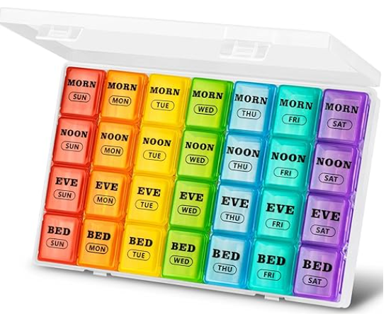 Up to 4x daily dosette box

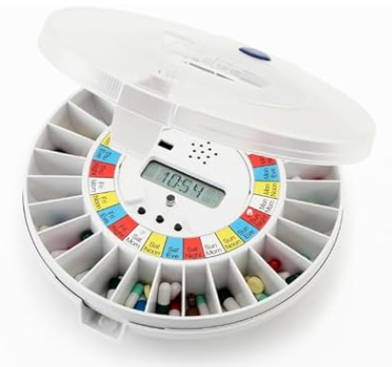 Pill dispensers with reminder alarm

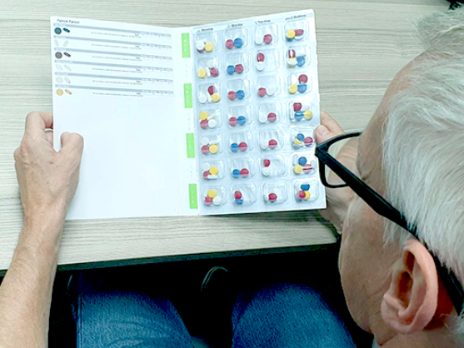 Blister packs, pre-filled by pharmacies

**Handling Medication**

Wash your hands before giving out any prescriptions.

If using creams, gels or ointments, wear gloves, otherwise your skin will be absorbing the drugs they contain too.

**What to Expect in Care Homes, Hospitals & Hospices**

The ‘6 R’s’ of Medication is guidance followed by health and social care staff.

The 6 R’s refer to:

* Right resident (patient / person)
* Right medicine
* Right route
* Right dose
* Right time
* Right to refuse (medication)

All prescribed medication is documented on a person’s individual Medication Administration Record known as a MAR Chart. This includes the person’s identifying information name / date of birth, weight of person and date that was last taken, dose, times, known allergies and reactions, the start and stopping of medications.

You can expect there to be a strong emphasis on involving people in decisions around taking medication in care homes, hospitals and hospices.

**What if my Loved One doesn’t want to take medication?**

Never force anyone to take medication, if your loved one is not taking medication for any reason, discuss this with the prescriber. Always talk with your GP or pharmacist before considering crushing or mixing drugs with food, some capsules are not to be opened in the air, other medications may react adversely, or not work once with other substances. Check for any alternative formats the medication can be taken.

The Mental Capacity Act follows the default that everyone can make decisions for themselves, unless proven otherwise. It also considers the types of choices a person can manage, so although it may not be possible for someone to evaluate that they are not safe to be at home, they could be able to decide not to have medication given to them at a particular time for example.

In these situations, a health professional or social worker can get involved to help determine what is in the person’s best interests, whilst maintaining the individual’s highest level of control and choice possible. If your loved one cannot make decisions, you can advocate for and make medical care and life-sustaining medical treatment decisions on their behalf with an ordinary (temporary) or lasting (enduring) Power of Attorney agreement in place. These arrangements vary across the UK nations and are called Health & Welfare (England and Wales), Welfare or Combined (Scotland), and is not available in Northern Ireland.

**Side-effects**

Look out for new patterns or changes in symptoms, behaviour, mobility, mood and cognitive abilities. If you think your loved one is experiencing side-effects contact your GP or local pharmacist.

In addition, you can record suspected side-effects of drugs to the ‘Medicines & Healthcare Products Regulatory Agency’ using their Yellow Card Scheme at <https://yellowcard.mhra.gov.uk/> You can also see what others are reporting about different drugs on their listing pages <https://yellowcard.mhra.gov.uk/idaps>

**Medication Reviews**

As well as reviewing medication with doctors, if your loved one is taking more than one medication, you can ask a pharmacist for a free medication review. This is an opportunity to talk through any concerns relating to any aspect of prescriptions and over-the-counter products being used.

Further Information

**NHS Medicines: Practical Tips if you Care for Someone**

<https://www.nhs.uk/conditions/social-care-and-support-guide/practical-tips-if-you-care-for-someone/medicines-tips-for-carers/#:~:text=Never%20give%20medicine%20to%20someone,always%20safe%20to%20do%20this>.

**National Institute for Clinical Excellence (NICE)**

**Guidelines for Managing Medicines in Care Homes**

<https://www.nice.org.uk/guidance/sc1/resources/managing-medicines-in-care-homes-pdf-17728301509>

Jacqueline Ede, PSPA